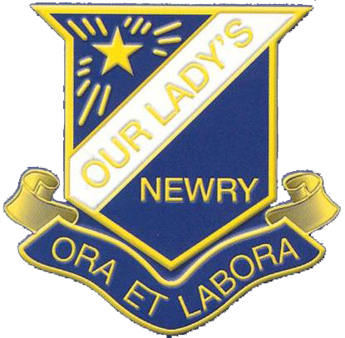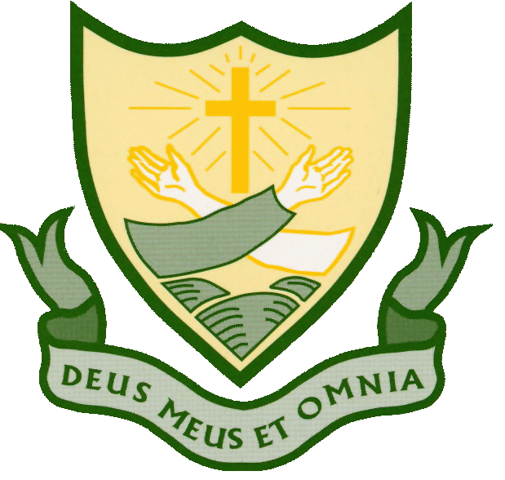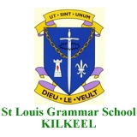

ENTRANCE ASSESSMENT for Transfer 2023

Post Primary Transfer Consortium
Entrance Assessments for Transfer 2023

Parents/Guardians of pupils presently in Primary 6, considering any of the schools listed below as possible post-primary schools for their children, are invited to register for an Entrance Assessment in English and Mathematics. All of the schools are using the same Entrance Assessment on Saturday 12th November 2022.

A Registration pack may be obtained in person, by writing to any of the schools listed or by downloading the pack from a school’s website.

Registration Packs will be available from 4th May 2022. Completed registration forms must be returned to the Newry & Mourne Registration Centre c/o Abbey Christian Brothers’ Grammar School no later than 2.00 pm on Friday 23rd September 2022.

ABBEY CHRISTIAN BROTHERS’ GRAMMAR SCHOOL
ST COLMAN’S COLLEGE
ST LOUIS GRAMMAR SCHOOL
OUR LADY’S GRAMMAR SCHOOL
SACRED HEART GRAMMAR SCHOOL

