Notes for April 2024
Diary Dates:
Tuesday 16th April Library Van visit
Thursday 18th April P6 Biodiversity workshop with Men’s Shed
Thursday 25th April Confirmation in St Patrick’s @11am

After School Clubs
- £14 for the month of April for P1/2 afterschool club, payable to the office.
- GAA Club continues every Thursday for P4-7 pupils. £10 for the term.
- New P3 Scratch Club beginning 16th April from 3-4pm for five weeks with Mrs Dodgson. Limited places so please return permission slip with £5 to the office asap.
- Film Club for P6/7 beginning Wednesday 24th April for 5 weeks with Mrs Lavery. Total cost £5, please return reply slip.
- Thanks to Mrs Cosgrove for leading our Spanish afterschool club and well done to all the pupils who attended. You can see an overview of some of the activities at: https://www.stmichaelsps.co.uk/news/spanish-club/

Also have a look on the website at the wonderful pottery pieces our P1/2 and P4 pupils made with Mary Cowan at our Art Club.
Stations of the Cross

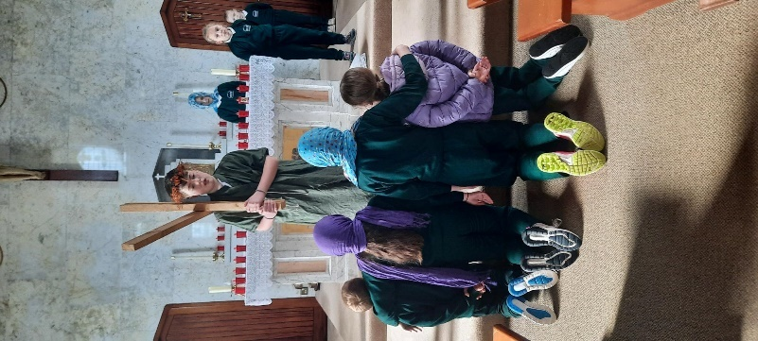
Congratulations to all the pupils from P5-7 who took part in the dramatisation of the Stations of the Cross in Holy Week. This was such a thought provoking and moving service enjoyed by the whole school community.
Special thanks to Mrs Lavery for preparing the pupils.

Trocaire
A total of £370 was collected for Trocaire: £160 raised through classroom boxes and £210 from family box donations. Money was presented to Canon Toner.
Big Spring Clean Up
The school (P3-7) will participate in a clean-up around the school, the Rural Hall and St Michael’s Church on the week beginning 29th April. Please complete permission slip.

Breakfast Club
It is great to have some many pupils attending our Daily Breakfast club. Can we please remind parents: pupils cannot enter school until 8.15am and are not to be left outside unsupervised. https://www.stmichaelsps.co.uk/news/breakfast-club-a/?p=3&tags=,1080,

Diversity Month
Have a look at the fantastic range of activities that pupils completed as part of our Diversity Month celebrations:
https://www.stmichaelsps.co.uk/news/diversity-and-celebration-month-in-st-michaels-ps/
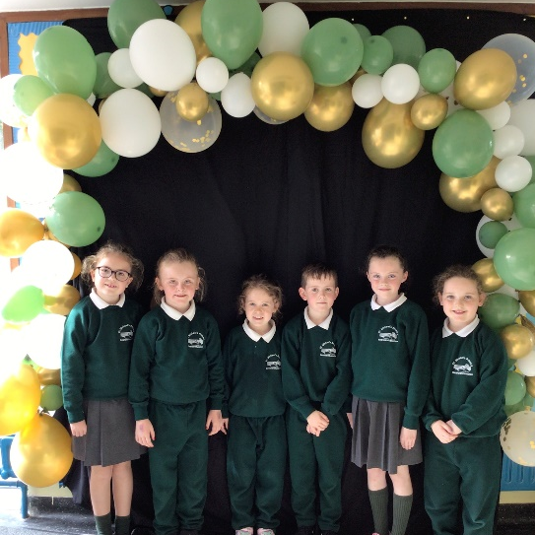
Special thanks to Mrs Lee for leading this initiative.

First Penance
Congratulations to our six wonderful P4’s who received the Sacrament of Reconciliation for the first time on Thursday 21st March and we look forward to their First Holy Communion in May!

Holiday List
Please see list of holidays on our website:
https://www.stmichaelsps.co.uk/parent-area/holidays/

Sacramental Dates

Thursday 25th April Confirmation (P7) in St Patricks, Cullyhanna @11am
Saturday 18th May First Holy Communion (P4)

School Holidays this term
Fri 3rd - Mon 6th May Bank Holiday weekend 1
Fri 24th - Mon 27th May Bank Holiday weekend 2
Fri 28th June School closes @11am for Summer!

Principal: Mr C Murphy, B.Ed (Hons), PQH(NI)
86 Dundalk Street,Newtownhamilton, Newry Co.Down BT35 0PB
Telephone No: 028 30 878 297 Website: www. https://www.stmichaelsps.co.uk

Big Spring Clean Up (for P3 – 7 only): (please return to class teacher)
I give permission for my child:
Name: __________________________
Class: __________
to participate in the school’s Big Spring Clean Up on the week beginning 29th April.

Signed: __________________

Scratch Club (for P3 only): (please return to office with £5)
I give permission for my child:
Name: __________________________
to participate in afterschool Scratch Club for 5 weeks beginning 16th April, total cost £5.

Signed: __________________

Film Club (for P6/7): (please return to office with £5)
I give permission for my child:
Name: __________________________
to participate in the afterschool Film Club for 5 weeks beginning 24th April, total cost £5.

Signed: __________________

