Saint Michael’s  Primary School | 

Notes for June 2023

Diary Dates:
Friday 2nd June Sports Day 1
6th - 7th June P7 overnight trip to YMCA
Wednesday 7th June P1/2 and P3/4 school trip to Fort Evergreen
Thursday 8th June After school GAA Club P5-7
Friday 9th June Little People Playgroup to visit
Monday 12th June P5/6 school trip to Airbound
Wednesday 14th June P7 pupils (Year 8 Sept) to attend St Paul’s High School
Monday 19th June Sports Day 2
Tuesday 20th June P7 Leavers’ Assembly @2pm for P7 parents
Friday 23rd June School closes @11.30 for Summer Holidays

P1/2 After School Club (Mon-Thurs) 2-3pm
£13 due for the month of June.

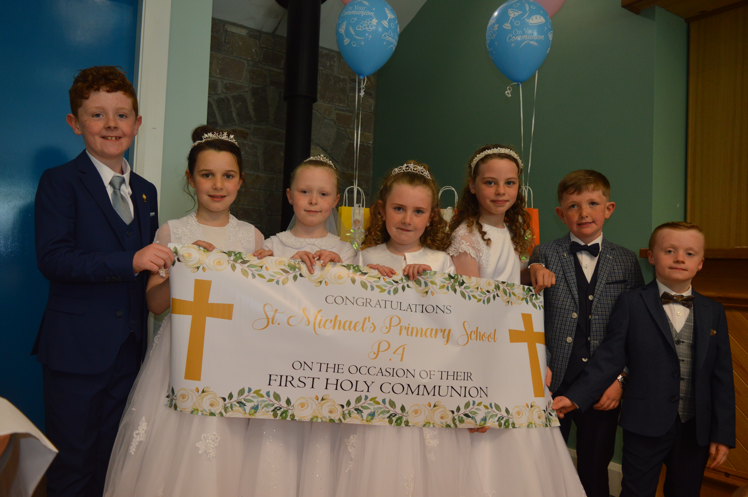
First Holy Communion 2022
Congratulations to our seven Holy Communicants who received the sacrament on Saturday 20th May. We are very proud of all of you!
Special thanks to all our staff but especially our P3/4 class teacher Mrs Dodgson, assistant Una Kirwan and Mrs Lee. On the day our Parent Association provided refreshments in the Rural Hall which we are very grateful for. Thanks also to Niamh Noade who sang and played the harp during the service. Look out for Niamh on the TV on 1st July as she competes in the Voice Kids.

Sports Days
This year we have planned three sporting events. On Friday 2nd June we have our traditional races and competitions, please wear school t-shirt and joggers or shorts. On Friday 9th June Little People Playgroup will visit for sports and staff familiarisation for some of our new P1’s. On Monday 19th June we have plans for a ‘Sports Fun Day’ with our GAA coach Karol, pupils can wear their GAA jerseys and shorts.

Gary Toner Memorial Blitz
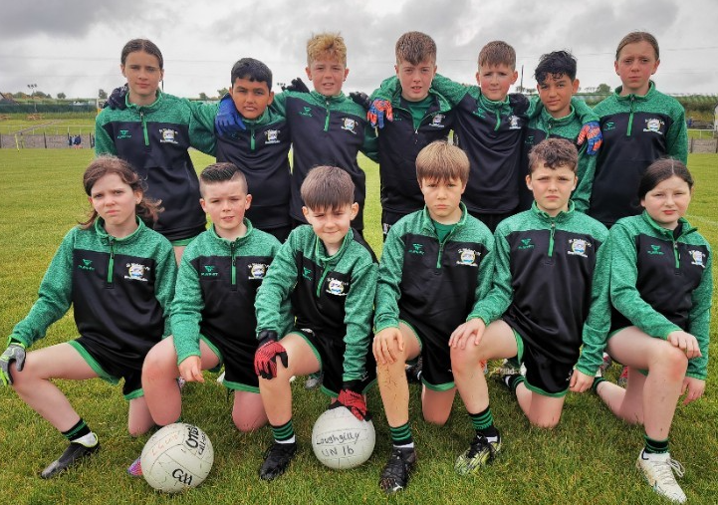
Our school football team travelled to Belleek GAC on 19th May to take part in the Gary Toner Tournament. They had a very successful day, winning 4 out of their 5 matches, which took them through to the final against Drumilly PS.
The game got off to a slow start, with Newtown down 3 points at half time whistle, but they came out fighting for their win in the 2nd half with some fantastic scores and teamwork from all the players. There were some fantastic skills throughout the whole match, and player of the match was awarded to Charlie McVerry for his fantastic scores and his determination to keep playing until the final whistle, even though he picked up an injury in the first half of the game.
We, as a school, are extremely proud of the team. Many thanks to Ciara for coaching our team on the day.

Attendance
Can we please remind parents that our Attendance Policy states that ALL absences must be reported to the school either in person or by phone. Please ensure you contact the school on the morning of the absence, or before if planned, and give a relevant and acceptable reason.


School Holidays this term

Friday 23rd June @11.30am School closes for Summer

