Saint Michael’s  Primary School | 

Notes for May 2022
Diary Dates:
Monday 2nd May School Closed- Bank Holiday
Tuesday 3rd May P6/7 visit Titanic Belfast
Saturday 21 May First Holy Communion @11am in St Michael’s Church
Monday 23rd May School Photographer

Afterschool clubs
Tuesdays Cycling Proficiency for P7 pupils, 3-4pm
Wednesdays Woodcraft Club for P5/6, 3-4pm
Thursdays GAA Club for all boys/girls from P5-7, 3-4pm

P1/2 After School Club (Mon-Thurs) 2-3pm
£15 due for the month of May.

Support for charities
A big thank you to all our families who generously supported our Trocaire fundraising during Lent, we raised a fantastic £125 which was presented to Fr Tremer.
£110 was also raised through our ‘Guess the Bear’ competition with money going to KBRT charity. Congratulations to Emma Riddle who guessed the name Archie. We wish Beth Preston well with her fundraising campaign and as she competes in Miss NI competition.

Assessment Week
Computer based assessments in Literacy and Numeracy for pupils in P3-7 will take place during the week of 9th May. Please ensure your child is not missing any day unnecessarily.

School trips
Please see below dates for our school trips in June. Each teacher will provide you with further details and consent forms must be signed.
CLASS | DATE | LOCATION
P3/4 | 09.06.22 | Gosford, Markethill
P1/2 | 14.06.22 | Gosford, Markethill
P6/7 | 17.06.22 | Greenhill YMCA, Newcastle
P5/6 | 24.06.22 | GR8, Castleblayney
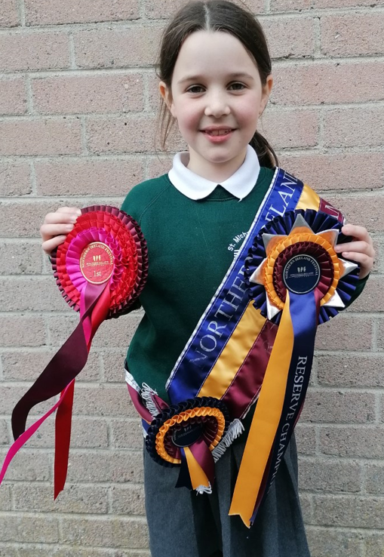
Show Jumping Success
A big CONGRATULATIONS to our superstar showjumper Lauren O Rourke from P3 who competed in the Northern Ireland Festival where she won a range of accolades. She follows in the footsteps of our famous past pupil Brian Hughes who was recently awarded British Champion Jump Jockey 2022.

Pupil sign In/Out
It is deemed good practice for schools to keep a record of pupils who are taken out of school early or arrive late for whatever reason. As and from Tuesday 3rd May we ask that parents come in to school and sign a record form for withdrawing your child or if they come in after school has started.

Big Spring Clean Up
During the week of 9th May we will undertake a clean-up within the grounds of the school, around Men’s Shed, Rural Hall and St Michael’s Church. Can parents of pupils in P5/6 and P6/7 please give consent as these pupils will be collecting litter off site?

Ten Foundation
We will be delighted to have Ian, from the Ten Foundation, back in St Michael’s PS on 7th June where he will present to classes all about his charity. We will be selling a range of schoolbags, lunch boxes and pencil cases in school the following week, where all monies raised will support vulnerable families in the Philippines.
Check out their web page at https://www.tenfoundations.org/



Sacramental Dates
Saturday 21st May First Holy Communion
Saturday 11th June Confirmation


School Holidays this term
Mon 2nd May Bank Holiday
Mon 30th May- Fri 3rd June May Holiday Week
Thursday 30th June @12noon School closes for Summer

P5/6 Woodcraft Club
I give permission for my child ________________________ to attend the Woodcraft Club starting Wednesday 4th May, 3-4pm, for 6 weeks.

Signed: ____________________

P5/6 and P6/7 Big Spring Clean Up
I give permission for my child ________________________ to take part in the Big Spring Clean Up off site.

Signed: ____________________

